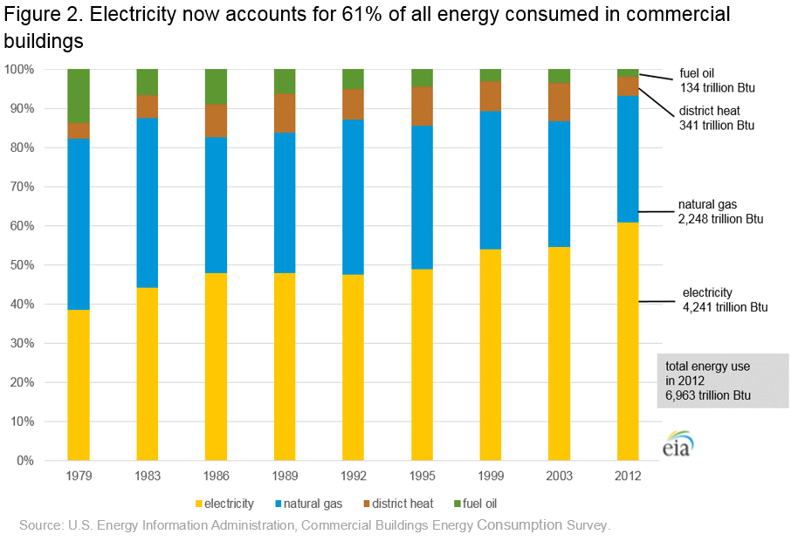<https://www.eia.gov/consumption/commercial/reports/2012/energyusage/images/fig2_new.png>

Review: accuracy in representation, possible comparisons, simplicity and clarity  
Review possible improvements to the figures.

The Stacked bar plot display a numeric value for several entities, organized in groups and subgroups. And sometimes it is used to study an evolution using each group on the X axis as a timestamp. This figure shows us the evolution of the proportion of energy consumed in commercial buildings so we can say that the choice of plot was good. the use of different color give the viewer more clarity and ability to recognize the consumption of different type of energy, the space between the bars make it easy to distinguish the evolution by years, the graph is simple to read because of the Claire legend and title and the organized structure. We can say that the graph make it easy to study the evolution of the consumption of the electricity regarding other types of energy. but the limit for this graph is that we can’t study the evolution of the consumption of each type at once due to the lack of numerical values, the second limit the figure doesn’t take in consideration all the years the gap between years is big 3 or 4 years the other note is that the scale of years is not constant, those lacks make it difficult to find patterns for the evolution.

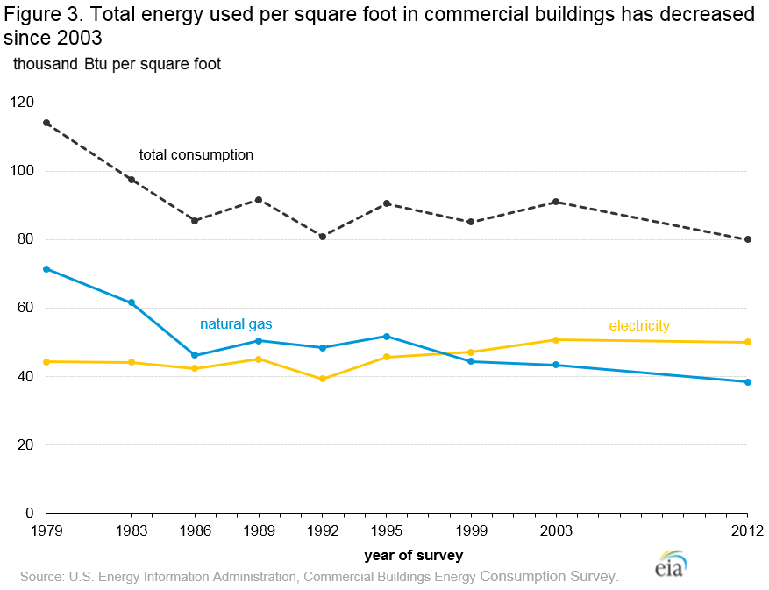<https://www.eia.gov/consumption/commercial/reports/2012/energyusage/images/fig3_new.png>

This graph is a line graph and it is another type of graph with strong ability to analyze the evolution on time, this Figures shows us the evolution of the consumption of natural gas and electricity and the total of both by square foot on years, the graph is accurate in terms of both years X Axis and consumption Y axis, colors make the view more simple and Claire, point on lines give the graph more accuracy and make it easy to break lines on specific consumption changes, to differentiate between the total and the consumption of gas and electricity each one at once the style of the line is different another point that gives the graph more clarity and simplicity.